%%%%%%%%%%%%%%%%%%%%%%%%%%%%%%%%%%%%%%%%%%%%%%%%%%%%%%%

**Example 3**

We apply the proposed scheme to solve aggregation-diffusion equation in an L-shaped area with



The initial data is

%%%%%%%%%%%%%%%%%%%%%%%%%%%%%%%%%%%%%%%%%%%%%%%%%%%%%%%

**Result**

1. **Free energy**

**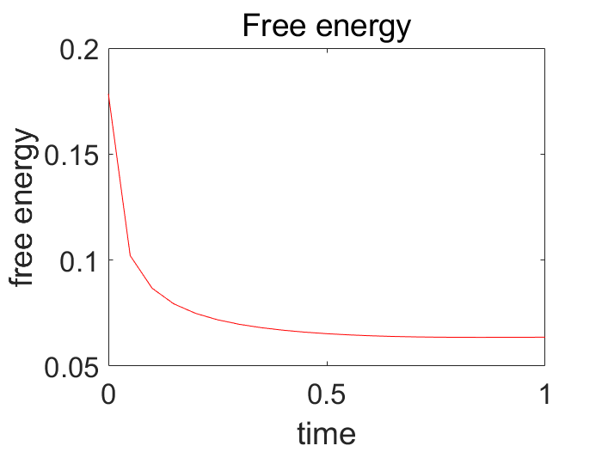**

Figure 1 Mesh size(1/32), time step(tau=1/60000)

1. **The total mass**

The total mass at n=0: 5.637030e-02\*\*\*\*\*

The total mass at T=5.000000e-02: 5.637030e-02\*\*\*\*\*

The total mass at T=1.000000e-01: 5.637030e-02\*\*\*\*\*

The total mass at T=1.500000e-01: 5.637030e-02\*\*\*\*\*

The total mass at T=2.000000e-01: 5.637030e-02\*\*\*\*\*

The total mass at T=2.500000e-01: 5.637030e-02\*\*\*\*\*

The total mass at T=3.000000e-01: 5.637030e-02\*\*\*\*\*

The total mass at T=3.500000e-01: 5.637030e-02\*\*\*\*\*

The total mass at T=4.000000e-01: 5.637030e-02\*\*\*\*\*

The total mass at T=4.500000e-01: 5.637030e-02\*\*\*\*\*

The total mass at T=5.000000e-01: 5.637030e-02\*\*\*\*\*

The total mass at T=5.500000e-01: 5.637030e-02\*\*\*\*\*

The total mass at T=6.000000e-01: 5.637030e-02\*\*\*\*\*

The total mass at T=6.500000e-01: 5.637030e-02\*\*\*\*\*

The total mass at T=7.000000e-01: 5.637030e-02\*\*\*\*\*

The total mass at T=7.500000e-01: 5.637030e-02\*\*\*\*\*

The total mass at T=8.000000e-01: 5.637030e-02\*\*\*\*\*

The total mass at T=8.500000e-01: 5.637030e-02\*\*\*\*\*

The total mass at T=9.000000e-01: 5.637030e-02\*\*\*\*\*

The total mass at T=9.500000e-01: 5.637030e-02\*\*\*\*\*

The total mass at T=1: 5.637030e-02\*\*\*\*\*

1. **Numerical result**

|  |  |  |
| --- | --- | --- |
| rho_h_fill3_0  Figure 2 t = 0 | rho_h_fill3_1  Figure 3 t = 0.05 | rho_h_fill3_10  Figure 4 t = 0.5 |
| rho_h_fill3_16  Figure 5 t = 0.8 | rho_h_fill3_18  Figure 6 t = 0.9 | rho_h_fill3_20  Figure 7 t = 1 |